ASSIGNMENT: LINUX
Module: 1 - Linux server - Understand and use essential tools

- What is the minimum number of partitions you need to install Linux?
Answer: Linux can be installed with just one partition, a root partition mounted at (/)
Swap can be provided as a swap file on this root partition, so a separate swap partition is not strictly required.
- Explain About Chmod Command
Answer: The chmod command in Linux is used to change file and directory permissions, determining who can read, write, or execute them. You can use symbolic notation (like u+x) or octal numbers (like 755) to set permissions for the owner, group, and others.
chmod Command
Purpose: Change file permissions

Permissions
- r = Read (4)
- w = Write (2)
- x = Execute (1)

Common Numbers
755 = rwxr-xr-x (scripts, folders)
644 = rw-r--r-- (files)
600 = rw------- (private files)

Basic Commands
chmod 755 file.sh # Make executable
chmod 644 file.txt # Normal file
chmod 600 key.txt # Private

Who Gets Permissions
rwx r-x r-x
│ │ └── Others
│ └── Group
└── Owner
Most used: chmod 755 + chmod 644

Symbolic Method (letters: u, g, o, r, w, x)
Examples
Give execute permission to user:
chmod u+x file.sh
Remove write permission from others:
chmod o-w file.txt
Give read & write permissions to everyone:
chmod a+rw file.txt

- How to check Linux memory utilization
Answer:
Check Linux Memory Usage
1. Quick Overview

(free -h: shows total, used, free, and available RAM and swap in a simple summary.)
Output:

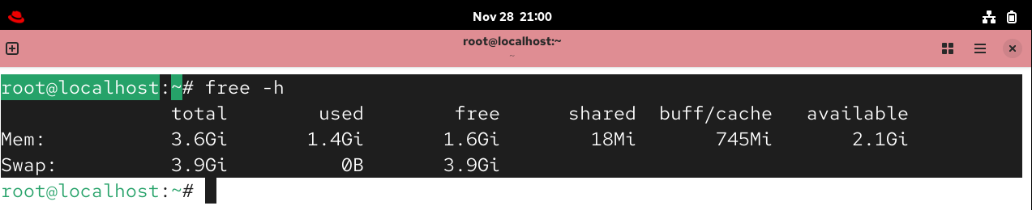

Command: (top or htop) – provides a real-time view of memory usage per process and overall system usage.
Output :
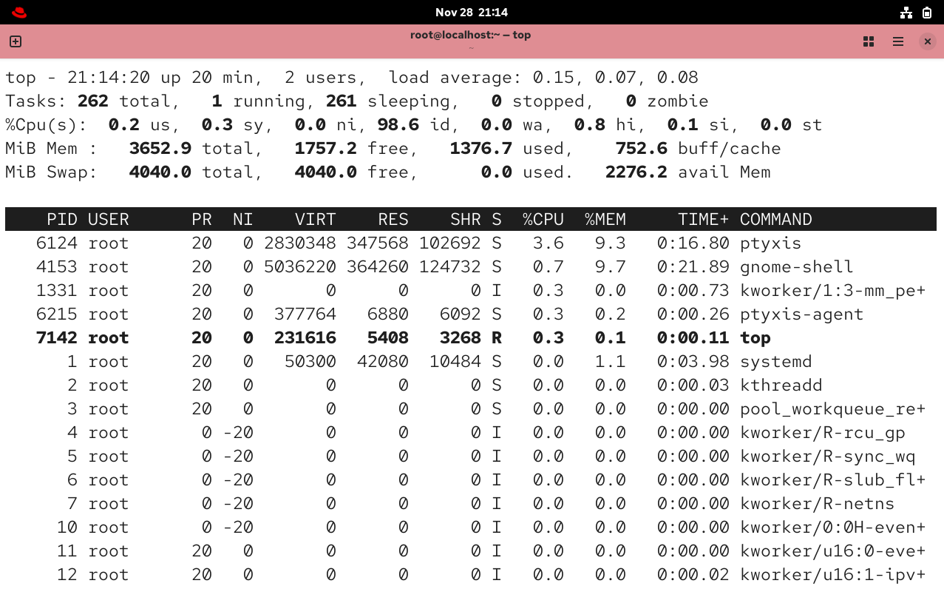

Command: (vmstat 1) – displays ongoing virtual memory statistics (processes, memory, paging, IO, CPU)
Output:
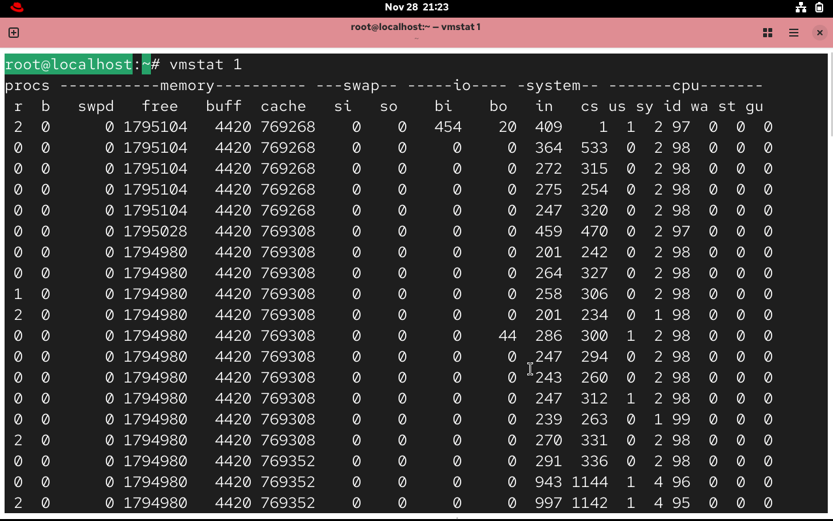
Command: (cat /proc/meminfo) – prints detailed kernel memory metrics for precise analysis
Output:
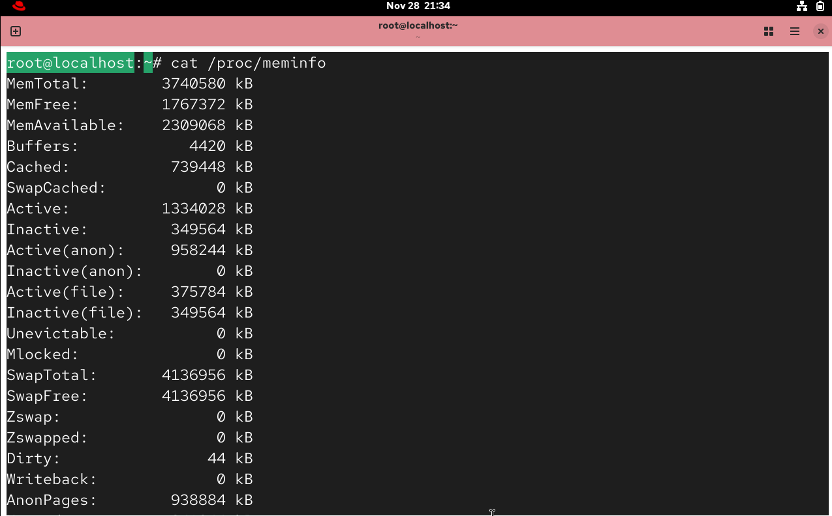

- · Use grep to search for specific patterns in files.
Answer:
1. Search a word in a file
grep "linux" file.txt
2. Search pattern in multiple files
grep "error" *.log
3. Case-insensitive search
grep -i "linux" file.txt
(Finds Linux, LINUX, liNuX, etc.)
4. Show line numbers
grep -n "root" /etc/passwd
5. Search recursively (all files in a folder)
grep -r "password" /etc/

6. Show only filenames that match
grep -l "error" *.log
7. Show lines that do not match
grep -v "error" file.txt
8. Count matching lines
grep -c "fail" /var/log/auth.log
9. Search whole word only
grep -w "root" file.txt
10. Use regular expressions
grep -E "error|fail|warning" server.log
(-E = Extended regex)

Table
Command | Description
grep "text" file | Search text in file
grep -i | Ignore case
grep -n | Show line numbers
grep -r | Recursive search
grep -l | Show only filenames
grep -v | Invert match
grep -c | Count matches
grep -w | Whole word match
grep -E | Use regex

- · Get Connecting on a linux server by ssh
Answer:
Basic Syntax
ssh username@server_ip
Example:
ssh root@192.168.1.10
1. Connect for the first time
ssh user@server_ip
It will ask:
Are you sure you want to continue connecting (yes/no)?
Type:
yes
Then enter your password.
2. Using a custom port (if SSH is not on port 22)
ssh -p 2222 user@server_ip
3. Connect with SSH key (no password login)
ssh -i /path/to/private_key user@server_ip
Example:
ssh -i ~/.ssh/id_rsa ubuntu@3.92.121.55
4. Copy files to server using scp
Upload file:
scp file.txt user@server_ip:/home/user/
Download file:
scp user@server_ip:/home/user/data.txt .
5. Generate SSH key (for key-based login)
ssh-keygen
Default path:
~/.ssh/id_rsa

6. Add your key to the server
On your local system:
ssh-copy-id user@server_ip

- Create 5 files in the /tmp directory, and then use tar and gzip to bundle and compress the files.
Answer: Create 5 Files in /tmp and Compress with tar + gzip
Bash
1. Create 5 files in /tmp
cd /tmp
touch file1.txt file2.txt file3.txt file4.txt file5.txt
echo "Sample content" > file1.txt
ls -l file*.txt # Verify files created

2. Bundle and compress with tar + gzip
tar -czvf backup.tar.gz file1.txt file2.txt file3.txt file4.txt file5.txt
Flags: -c (create), -z (gzip), -v (verbose), -f (filename)

3. Verify archive
ls -lh backup.tar.gz # Check compressed size
tar -tzf backup.tar.gz # List contents

- Describe the root account
Answer: The root account is the superuser with UID 0, possessing unrestricted access to all system files, commands, and resources.​
Key Characteristics
- Full privileges: Can read/write/execute any file, install software, manage users, configure hardware/networking, and modify kernel parameters.​
- Default home: /root directory; login shell typically /bin/bash.​
- Security risks: Direct root login often disabled; use sudo for elevated privileges instead.​
Access Methods
- Switch to root: su - or sudo -i
- Temporary privileges: sudo command
- Check identity: whoami or id (shows UID=0 for root)

8. What is shell?
Answer: The shell in Linux is a command-line interpreter program that acts as an interface between the user and the operating system kernel, accepting human-readable commands and executing them.​
Key Functions
- Command execution: Parses user input (e.g., ls, grep) and runs programs or built-ins.​
- Scripting: Enables automation via shell scripts for tasks like backups or monitoring.​
- File/process management: Handles I/O redirection, pipes (|), variables, and loops. ​
Common Shells
- Bash (default on most distros): Feature-rich with scripting support.
- Zsh, Fish: Enhanced with better autocompletion and themes.
- Check current shell: echo $SHELL

9. What is Linux?
Linux Operating System
Definition: Linux is an open-source, Unix-like operating system kernel created by Linus Torvalds in 1991, forming the core of complete distributions (distros) like Ubuntu, Fedora, CentOS.​
Key Components:
- Kernel: Manages hardware (CPU, memory, devices), processes, file systems.​
- Shell: Command-line interface (Bash) for executing commands/scripts.​
- User Space: GNU tools, libraries, daemons, desktop environments (GNOME/KDE).​

Main Features:
- Open Source: Free, modifiable under GPL license.​
- Multi-user/Multitasking: Supports multiple concurrent users/processes.​
- Portable: Runs on servers, desktops, Android, supercomputers.​
Uses: Powers 90%+ web servers, Android, embedded systems, supercomputers.

10. What is Bash?
Answer:
What Bash Does
Bash allows you to:
- Type commands to interact with the operating system
- Run programs
- Manage files and directories
- Automate tasks using shell scripts
Why It’s Called “Bourne Again”
It is an improved version of the earlier Bourne Shell (sh), created as a “born again” replacement—hence the pun.
Where Bash Is Used
- Default shell on most Linux distributions
- Available on macOS
- Can be used on Windows through WSL (Windows Subsystem for Linux)
- Used widely in scripting, automation, system admin, DevOps, etc.
Example Bash Command
mkdir new_folder
Creates a new directory.
Example Bash Script
#!/bin/bash
echo "Hello, World!"

11. You have a new empty hard drive that you will use for Linux. What is the first step you use.
Answer:
Create Partitions on the Hard Drive
Before installing Linux, the drive must be partitioned so the installer knows how to store data.
This includes:
- Creating a partition table
  - Usually GPT (modern systems)
  - Or MBR (older systems)
- Creating partitions such as:
  - Root ( / ) – main Linux system
  - Swap – virtual memory
  - Home ( /home ) – user files (optional but recommended)
Where This Happens
You typically do this during the Linux installation process using the installer’s partitioning tool:
- Ubuntu Installer (Ubiquity / Subiquity)
- Fedora Installer (Anaconda)
- Debian Installer
- etc.

12. Write the Linux command to show the current working directory.
Answer:
Linux command to show current working directory: pwd​
Explanation:
pwd (Print Working Directory) displays the full absolute path of your current location in the filesystem (e.g., /home/user/docs).​
Example:
$ pwd
/home/user
13. write the Linux command to get help with various options.
Answer:
1. Using the --help option
Shows a quick help :
command --help
Example:
ls --help
2. Using the man command
Opens the full manual (detailed documentation):
man command
Example:
man ls

14. Write the Linux command to display what all users are currently doing.
Answer: To display what all users are currently doing in Linux, use:
Command: W
The w command shows:
- Logged-in users
- Their login times
- What processes/commands they are currently running

15. write the Linux command to get information about the operating system.
Answer:
Most Common Command
uname -a
This shows kernel name, version, machine type, and more.
To get detailed OS info (recommended)
cat /etc/os-release
This displays the name, version, and other details of the Linux distribution.
Optional
hostnamectl
Also shows OS info along with kernel and hardware details.
So, the primary command is:
uname -a
or
cat /etc/os-release

16. Write the Linux command to create a hard link of a file.
Answer:
The Linux command to create a hard link of a file is:
ln source_file hardlink_name
Example:
ln file1.txt file1_hardlink.txt

17. Write the Linux command to create a soft link of a file as well as Directory.
Answer:
1. Soft link (symbolic link) for a file
ln -s source_file link_name
Example:
ln -s file1.txt file1_link.txt
2. Soft link for a directory
ln -s source_directory link_name
Example:
ln -s /home/user/Documents docs_link
Summary
- Soft link for a file → ln -s file link
- Soft link for a directory → ln -s directory link
18. Write the Linux command! to search for specific pattern in a file.
Answer:
Linux command:
grep "pattern" filename
Example:
grep "error" log.txt
19. Write the Linux command to show the use of basic regular expressions using grep command.
Answer:
Linux command:
grep “pattern” filename
Examples of basic regular expressions with grep:
- Search lines starting with a pattern
grep "^start" filename
- Search lines ending with a pattern
grep "end$" filename
- Search for any one character
grep "t.st" filename
- Search for zero or more occurrences
grep "go*" filename
General example command for demonstrating basic regex:
grep "^a.*b$" filename

